

# CCT College Dublin Continuous Assessment

|  |  |  |  |
| --- | --- | --- | --- |
| **Programme Title:** | HDip in Artificial Intelligence | | |
| **Cohort:** | PT | | |
| **Module Title(s)**: | AI Concepts to Implementation | | |
| **Assignment Type:** | Individual | **Weighting(s)**: | 50% |
| **Assignment Title:** | Continuous Assessment 1 | | |
| **Lecturer(s)**: | Vikas Tomer | | |
| **Issue Date:** | 7th March 2024 | | |
| **Submission Deadline Date:** | 14th April 2024 | | |
| **Late Submission Penalty:** | Late submissions will be accepted up to **5** calendar days after the deadline. All late submissions are subject to a penalty of **10%** of the mark awarded.  Submissions received more than 5 calendar days after the deadline above **will not**  be accepted and a mark of 0% will be awarded. | | |
| **Method of Submission:** | **Moodle** | | |
| **Instructions for Submission:** | Submit one zip archive file containing a PDF version of your report, data sets and any supporting information | | |
| **Feedback Method:** | **Results posted in Moodle gradebook** | | |
|  |  | | |

**Learning Outcomes:**

Please note this is not the assessment task. The task to be completed is detailed on the next page. This CA will assess student attainment of the following minimum intended learning outcomes:

1. Demonstrate an understanding of the concepts and theories behind Artificial Intelligence and be aware of the historical context of the initial research and how this has evolved to its current state. (Linked to PLO 1)
2. Distinguish the different agents and environments of current Artificial Intelligence, being aware of consideration to perception / action and potential changes to environment. (Linked to PLO 3)
3. Demonstrate an understanding of the differences and challenges involved in developing different levels of Artificial Intelligence. (Linked to PLO 2)
4. Discuss the limitations of current A.I. research and the ethical and social impact of this research. (Linked to PLO 8)

Attainment of the learning outcomes is the minimum requirement to achieve a Pass mark (40%). Higher marks are awarded where there is evidence of achievement beyond this, in accordance with QQI Assessment and Standards, Revised 2013, and summarised in the following table:

|  |  |  |  |
| --- | --- | --- | --- |
| **Percentage Range** | **CCT**  **Performance**  **Description** | **QQI Description of Attainment** | |
| **Level 6, 7 & 8 awards** | **Level 9 awards** |
| 90% + | Exceptional | Achievement includes that required for a Pass and in **most** respects is significantly and consistently beyond this | Achievement includes that required for a Pass and in **most** respects is significantly and consistently beyond this |
| 80 – 89% | Outstanding |
| 70 – 79% | Excellent |
| 60 – 69% | Very Good | Achievement includes that required for a Pass and in **many** respects is significantly beyond this | Achievement includes that required for a Pass and in **many** respects is significantly beyond this |
| 50 – 59% | Good | Achievement includes that required for a  Pass and in **some** respects is significantly beyond this | Attains all the minimum intended programme learning outcomes |
| 40 – 49% | Acceptable | Attains all the minimum intended programme learning outcomes |
| 35 – 39% | Fail | Nearly (but not quite) attains the relevant minimum intended learning outcomes | Nearly (but not quite) attains the  relevant minimum intended learning outcomes |
| 0 – 34% | Fail | Does not attain some or all of the minimum intended learning outcomes | Does not attain some or all of the minimum intended learning outcomes |

Please review the CCT Grade Descriptor available on the module Moodle page for a detailed description of the standard of work required for each grade band.

The grading system in CCT is the QQI percentage grading system and is in common use in higher education institutions in Ireland. The pass mark and thresholds for different grade bands may be different from what you have experience of in the higher education system in other countries. CCT grades must be considered in the context of the grading system in Irish higher education and not assumed to represent the same standard the percentage grade reflects when awarded in an international context.

# Assessment Tasks

Students are advised to review and adhere to the submission requirements documented after the assessment task.

Task 1 **(25 marks)**

Research and investigate two Artificial Intelligence (AI) strategies that have been used to play chess. Describe and explain in your own words the theory and concepts used within these strategies and how they relate to AI.

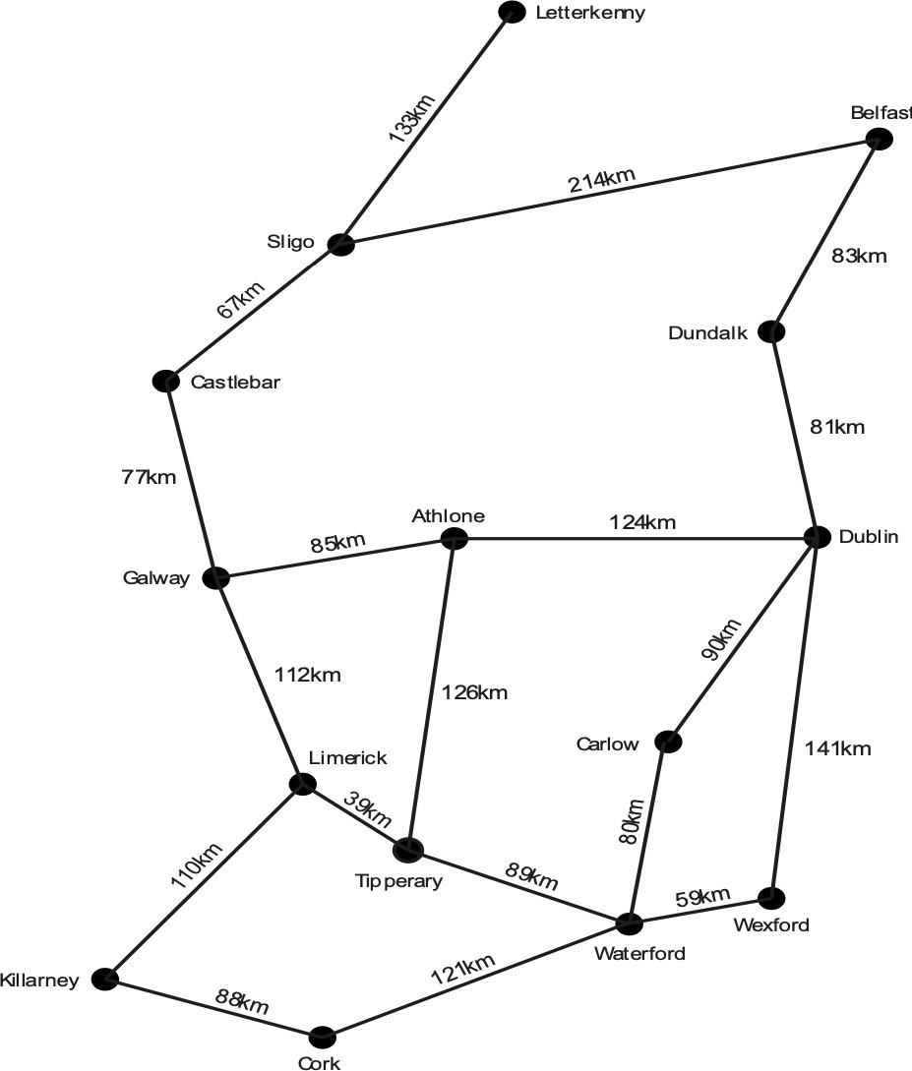

Task 2 **(50 marks)**

The weighted graph above shows cities and towns in Ireland as the nodes and connections between them as the edges. Distances between the nodes are shown in kilometers. We will use this in the context of finding the best route between a pair of locations.

1. Using the graph on the previous page, find a route **from Tipperary to Sligo**, using the following path- finding approaches implement both algorithms programmatically and compare the solutions generated in Mark-up (Note additional marks for including time statistics). Justify why one solution is better than other considering pros and cons of both algorithms.

# (30 marks)

* 1. **Either** depth-first search **or** breadth-first search [10 marks]
  2. Dijkstra’s algorithm [10 marks]
  3. The A* algorithm [10 marks]

1. AI has been essential in computer games since the 1960s. Provide an example of two AI strategies that are used in modern games by providing the appropriate references. You should identify the algorithm being used and why it was chosen, provide a high-level description of the algorithm and provide an example of a game where this algorithm has been implemented.

# (20 marks)

Task 3 **(25 marks)**

[Apollo](https://apptronik.com/apollo) is a general-purpose humanoid robot developed by Apptronik, [announced](https://spectrum.ieee.org/humanoid-robot) in August 2023. You can find the information at <https://apptronik.com>.

1. Discuss the AI characteristics that you think the [Apollo](https://apptronik.com/apollo) exhibits and illustrate by pointing the part of Apollo. [15 marks]
2. Explain AI characteristics that you think it still lacks and justify by highlighting your arguments. [15 marks]

# Submission Requirements

All assessment submissions must meet the minimum requirements listed below. Failure to do so may have implications for the mark awarded.

All assessment submissions must:Be submitted by the deadline date specified or be subject to late submission penalties

* Use Harvard Referencing when citing third party material
* Be the student’s own work.
* Include the CCT assessment cover page.
* Max 1000 words are allowed to support the justification/ explanation of the answers.

# Additional Information

* Lecturers are not required to review draft assessment submissions. This may be offered at the lecturer’s discretion.
* In accordance with CCT policy, feedback to learners may be provided in written, audio or video format and can be provided as individual learner feedback, small group feedback or whole class feedback.
* Results and feedback will only be issued when assessments have been marked and moderated / reviewed by a second examiner.
* Additional feedback may be requested by submitting a question to the discussion forum. Additional feedback may be provided as individual, small group or whole class feedback. Lecturers are not obliged to respond to email requests for additional feedback where this is not the specified process or to respond to further requests for feedback following the additional feedback.
* Following receipt of feedback, where a student believes there has been an error in the marks or feedback received, they should avail of the recheck and review process and should not attempt to get a revised mark / feedback by directly approaching the lecturer. Lecturers are not authorised to amend published marks outside of the recheck and review process or the Board of Examiners process.
* Students are advised that disagreement with an academic judgement is not grounds for review.
* For additional support with academic writing and referencing students are advised to contact the CCT Library Service or access the CCT Learning Space.
* For additional support with subject matter content students are advised to contact the CCT Student Mentoring Academy
* For additional support with IT subject content, students are advised to access the CCT Support Hub.